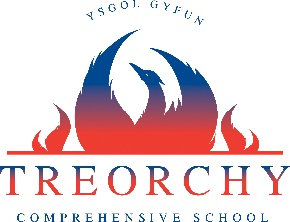

Update for all Year 10 pupils expecting results Summer 2020

- Year 10 pupils will be given a calculated grade for English Literature based on pupil’s work throughout the Literature course taking into consideration what they would have achieved during the absence period for Covid-19, as well as the outcome of the examinable units’ pupils had already sat during Year 10. The calculated results will also take into consideration if a pupil were due to resist any of these examinable units.

- Year 10 Pupils due to sit GCSE Maths will also be given a calculated grade based on their work throughout the GCSE course taking into consideration what they would have achieved during the absence period for Covid-19.

- Year 10 Pupils following BTEC courses will be given calculated grades for any internally assessed units which would have been undertaken during the absence period. The internally calculated units will be based on what a pupil could have achieved during the absence period for Covid-19.

- Pupils in Year 10 due to sit single GCSE or AS units however will not be awarded a calculated grade for the single unit. This will be taken into account with the revised assessment plan created by the exam board next year.

Results Days

- GCSE and Level 2 results will be available on August 20th, 2020
- AS, A Level and Level 3 results will be available on August 13th, 2020
- We cannot confirm currently how the results days will be organised but will update parents and pupils as soon as we have more information.

