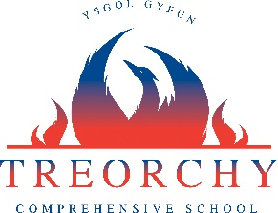

Update for all Year 12 pupils expecting results Summer 2020

- Year 12 pupils will be given calculated grades based on their work throughout the AS course and taking into consideration what they would have achieved during the absence period for Covid-19. This includes any resit for GCSE English and Maths.

- Year 12 pupils following BTEC courses will be given calculated grades on any units which would have been undertaken during the absence period. This calculated units will be based on what a pupil could have achieved during the absence period for Covid-19.

Results Days

- GCSE and Level 2 results will be available on August 20th, 2020
- AS, A Level and Level 3 results will be available on August 13th, 2020
- We cannot confirm currently how the results days will be organised but will update parents and pupils as soon as we have more information.

