Pupil Guide
How to Access Microsoft Teams

Work will be set for pupils through Microsoft Teams, which is part of the Microsoft Office 365 package.
In order to access Microsoft Teams pupils will need to go to the Hwb website (www.Hwb.gov.wales) and click on the log in button towards the top right hand corner. Once logged in pupils will see the following page.
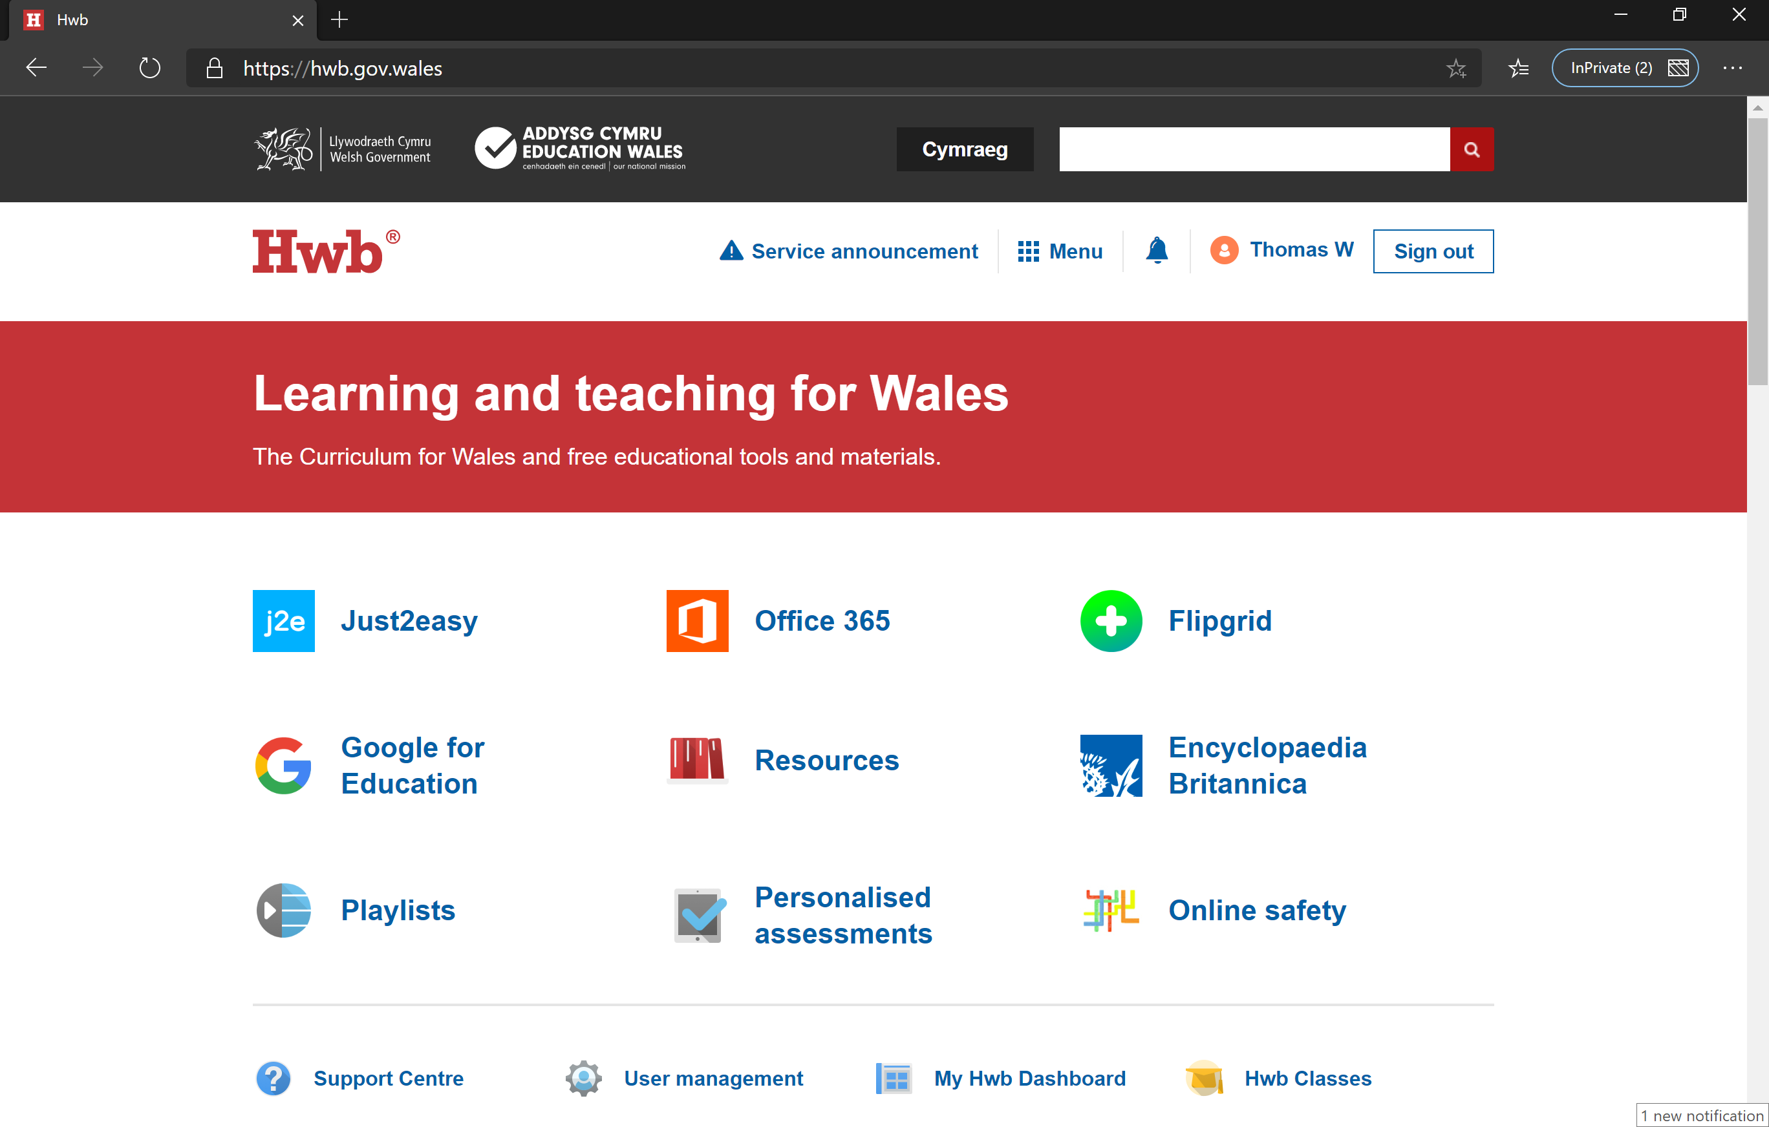
Pupils should then select Office 365 ….

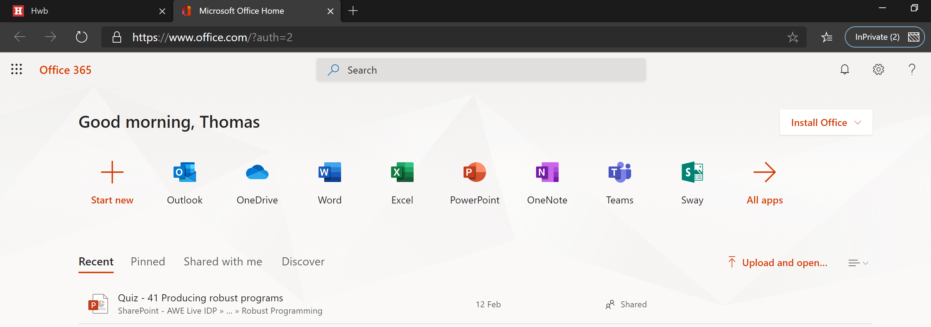
… and Teams.

Pupils in Years 7-10
When Teams opens pupils will see the following screen. You will then see a list of the Teams you are a member of.
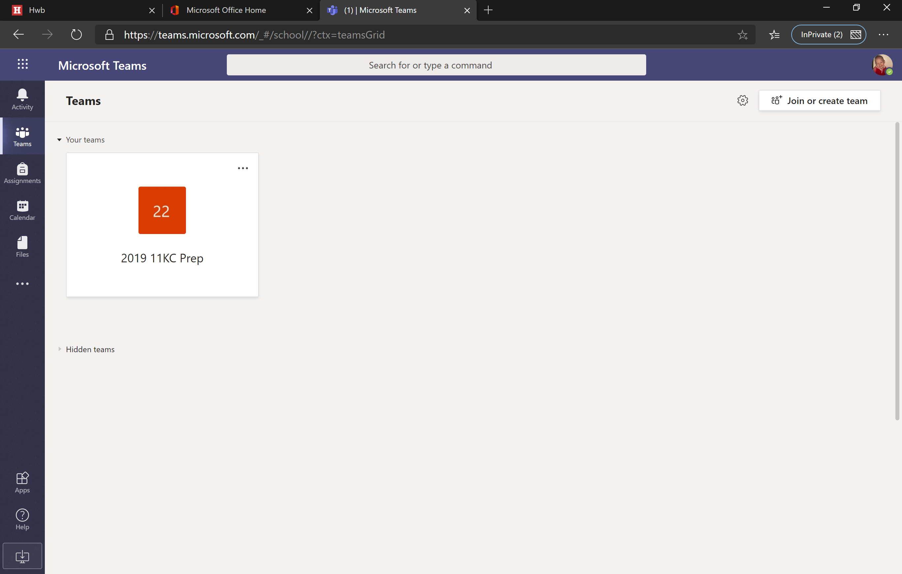
Pupils should then select their Prep class team.
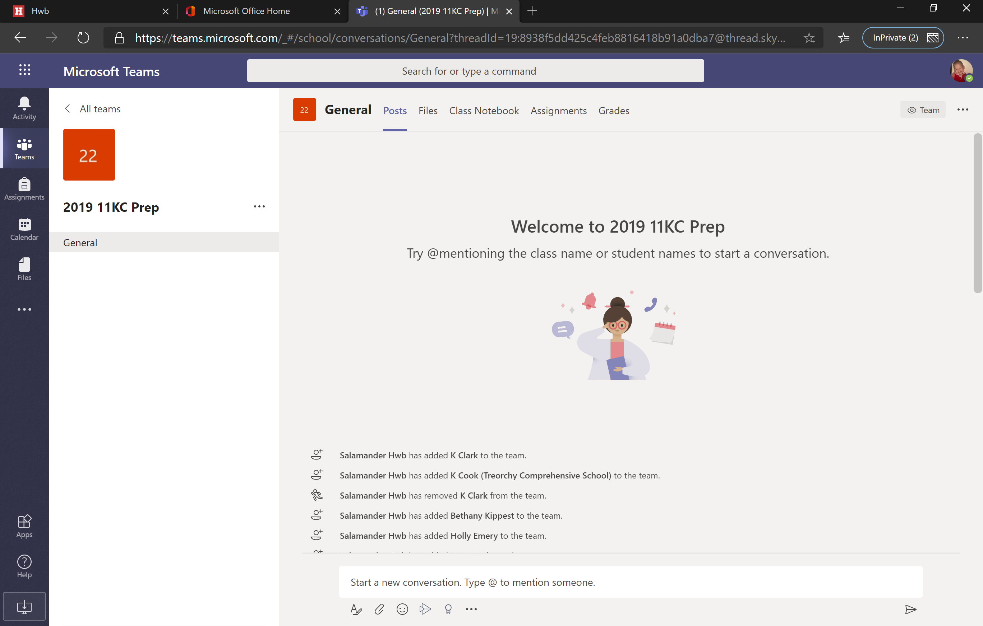The Team is now open. Pupils will be able to access materials in the first instance by clicking on the files tab and clicking on the class materials folder.
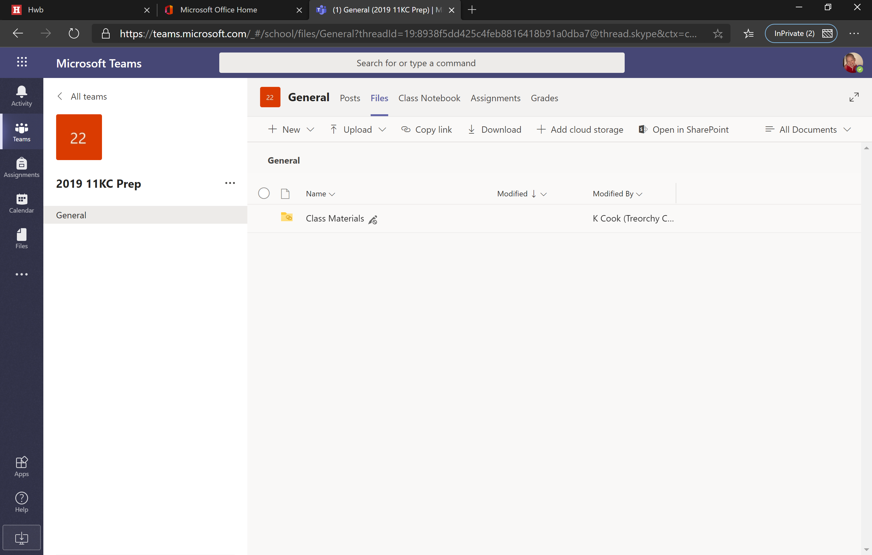
In this folder pupils will find work, which can be completed on paper.
Pupils in Year 12
When Teams opens pupils will see the following screen.
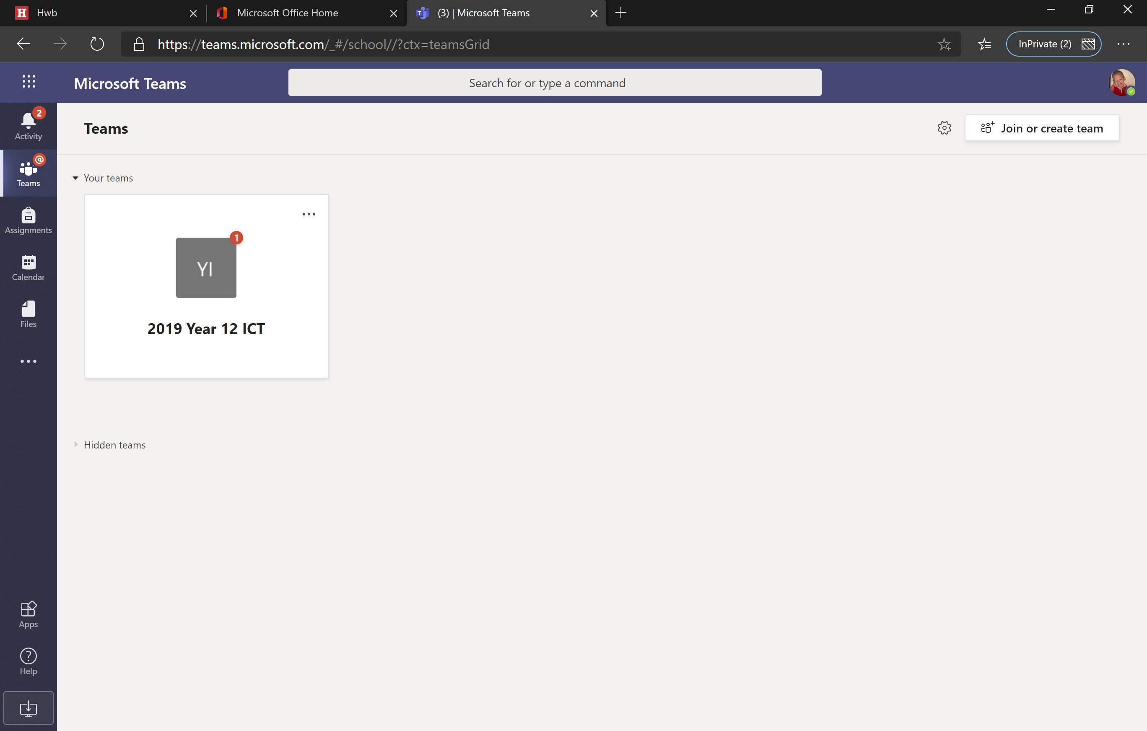
You will see all of your classes. Select the team you want to complete work for. The 1 in the red circle shows that there is a notification for this team.
The Team is now open. Pupils will see assignments which have been set.
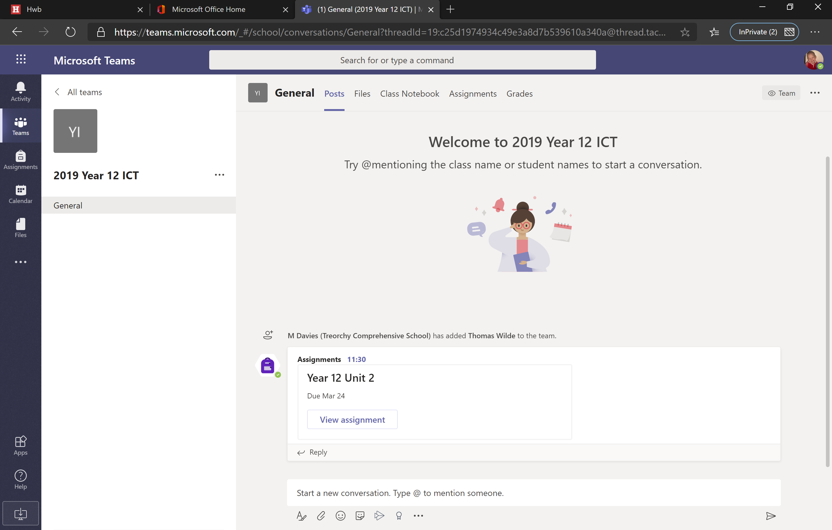
When a pupil clicks on the view assignment button the assignment will open.
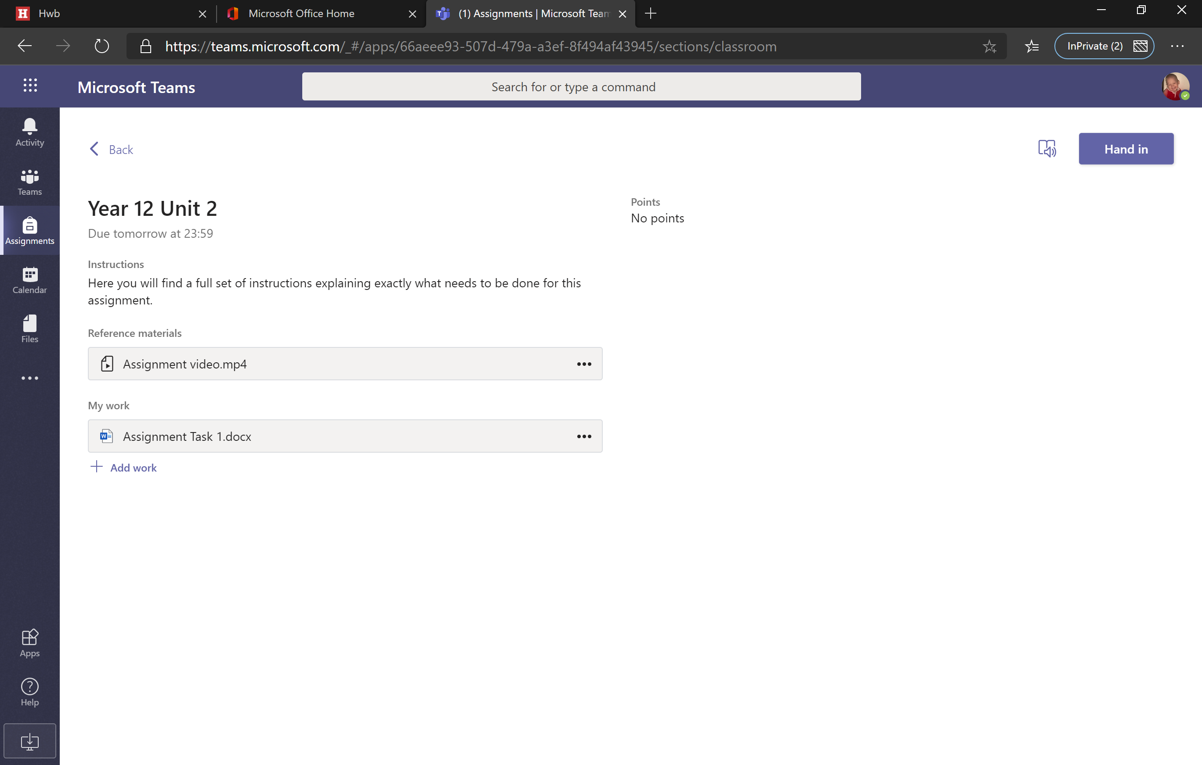
Here you will see all of the assignment details. There will be the full instructions on what needs to be completed, reference materials and in the my work section, the document that you need to complete. When you click on the document under my work it will open in word online.
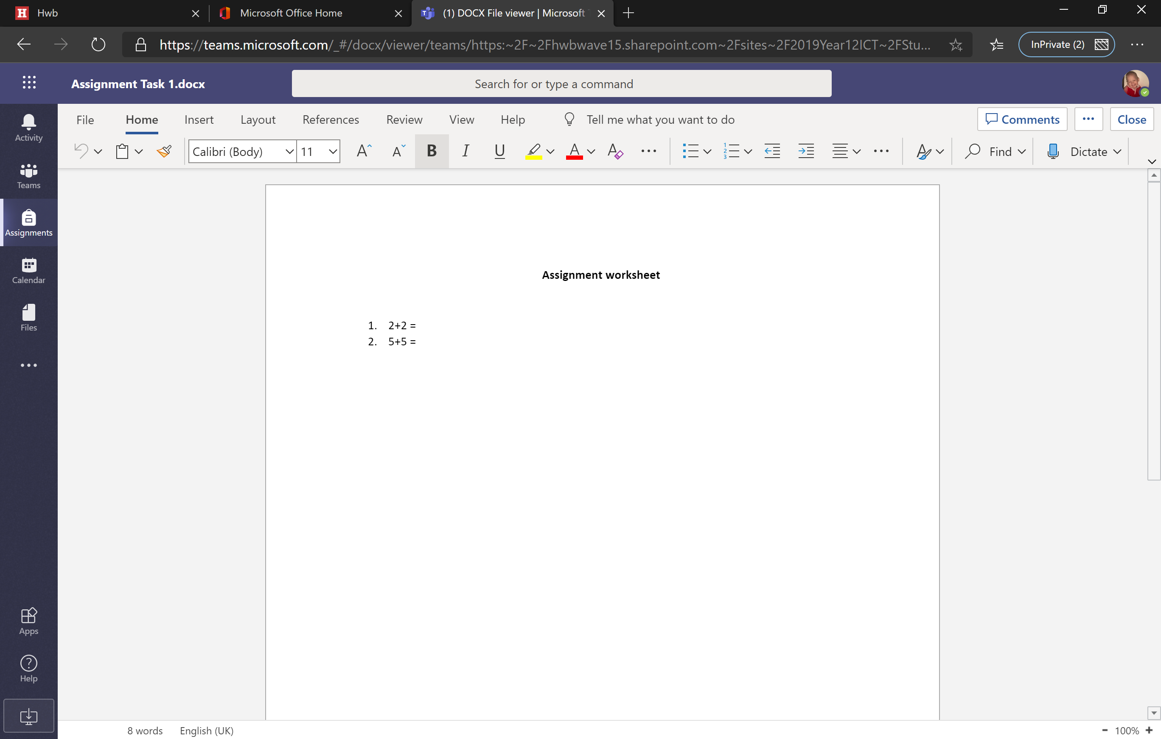
Here is where you will complete your work. When you have finished your work, or are stopping for a while, press close. This does not submit your work and you will be able to go back to this later. Your work will be saved as you complete it.
Your work will only be submitted when you click on the “Hand in” button in the top right hand corner.

