Wellbeing Directory
January 2021
Support | Description | Contact details
 | General support from School | Support@treorchycomp.org.uk  Tel 01443 773128
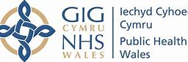 | Public health Wales | www.phw.nhs.wales
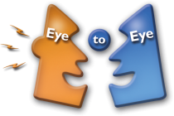 | Eye to Eye Counselling | www.eyetoeye.wales  tel. 01443 202940
 | Childrens’ Services  safeguarding support for Adults and Children | tel. 01443 742928
 | Educational Psychology | EPS@rctcbc.gov.uk
 | Childline  ChildLine is a counselling service for children and young people up to their 19th birthday in the UK provided by the NSPCC | www.childline.org.uk  tel. 08001111
 | Think you know  Educational programme which protects children both online and offline | www.thinkyouknow.com
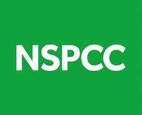 | NSPCC  National Society for the Prevention of Cruelty to Children. | www.nspcc.org.uk
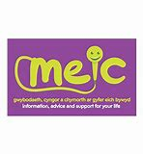 | Meic  Meic is the helpline service for children and young people up to the age of 25 | www.meicymru.org  Tel 080880 23456
 | Young Minds  The is the UK’s leading charity fighting for children and young people's mental health | www.youngminds.org.uk
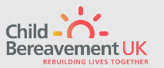 | Child Bereavement services | www.childbereavement.org  Tel. 080002 888 40
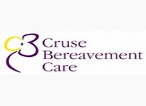 | Cruse  Cruse is a service offering support for families facing tragic loss of life. | www.cruse.org.uk  tel. 0808 8081677
 | Talk to Frank  Talk to Frank support advice and facts on drugs and alcohol | www.talktofrank.com

A Young Person’s Mental Health Toolkit can be found on Hwb. This comprises a variety of online resources, which can help them through lockdown and beyond. It contains information on websites, apps, helplines, and more, which support mental health and well-being:
- Anxiety https://hwb.gov.wales/go/agg9pn
- Coronavirus and your well-being https://hwb.gov.wales/go/ffkbs1
- Crisis https://hwb.gov.wales/go/4ypw1s
- Keeping health https://hwb.gov.wales/go/nz95en
- Loss https://hwb.gov.wales/go/lvy6hx
- Low mood https://hwb.gov.wales/go/bi4vbc

