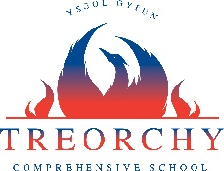
Year 9 Online Provision
Dear Parent/Carers
As a school we want to thank our parents/carers for their support of our teachers’ work in term of blended learning. We also want to thank the majority of our students who are engaged in their lessons and showing huge resilience and independence.
Since returning to school we have been working to improve our blended learning offer. I wanted to remind all parents/carers that blended learning involves a range of activities, including ‘live’ lessons, activities, quizzes and assignments.
All our blended lessons are designed to last for 45 minutes and not the 55 minute face-to-face in-school experience. This is because online learning is more continuous and therefore more intense than traditional in-class learning. All students can, of course, return to the learning experience after the lesson and may want to continue tasks/learning independently, as they would for homework. Some students may want to tackle extension work and the aim is to have examples of this available for each subject. There is also a wide range of learning available online; ‘Lockdown Learning’ is a good example of this, which is a BBC online learning package for all year groups. All students are also encouraged to read for pleasure and as widely as possible.
All students have been taught to access Microsoft Teams via Hwb as this is the platform we use for our blended learning and a guide can also be found on the school website (www.treorchycomp.org.uk) . All students should know their Hwb username and password. If your son/daughter needs any further support then please do not hesitate to contact the school (support@treorchycomp.org.uk or via telephone). Also, our students will need a device to access their learning; if this is currently an issue for you then can you let the school know.
Please see below, the learning offer for your child’s year group. The ‘live’ lessons will be communicated to the learners at least 24 hours before the lesson. Your son/daughter will follow their usual timetable; the times of lessons are provided again below.
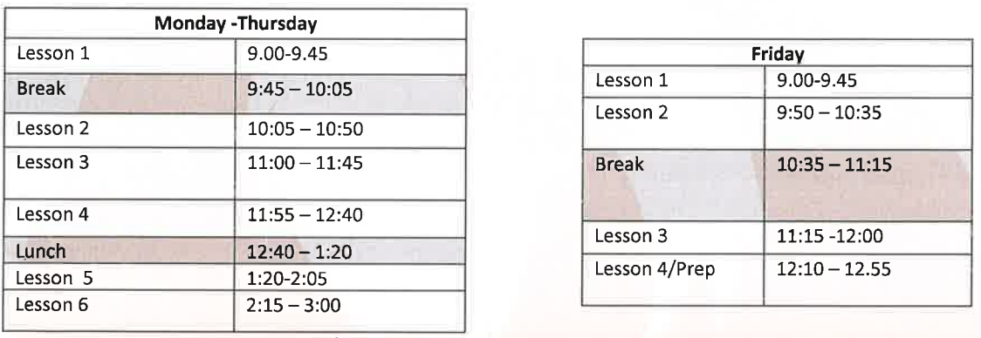
This blended offer has been running from 11th January. On January 29th we will send you a brief online survey so you can give us some honest feedback. The aim of this is for you to let us know what we can do better. We will also be holding a number of year group Information Evenings: the first of these will be a Year 11 information evening on Thursday 28th January, 6pm, delivered through Teams. Further details on this event and other future events will follow in due course.
Once again, thank you for your ongoing support. We very much look forward to returning to our real school experience.
Yours faithfully
Jennifer Ford
Learning Offer – Year 9
Please find below information relating to the online provision that we are offering our Year 9 pupils from 18th January 2021, across all curriculum areas.
Below the table you will find further information relating to methods of feedback for pupils and other opportunities and support being provided.
Subject | Live lessons per week | Blended learning lessons per week
English | 2 | 2
Maths | 2 | 2
Science | TA - 1 per week | 2 (for TA 3)
Welsh | 1 for Fast Track | 1
Sport | 1 | 2
PE (GCSE) | 1 | 2
Core PE | 0 | 1 to 2
Learning in the Outdoors | 1 per week | 2
Music | 5 per fortnight | 0
Drama | 5 per fortnight | 0
Performing Arts | 4 per fortnight | 1
History | 0 | 2
Geography | 1 | 1 or 2 depending on size
RE | 0 | 2 lessons uploaded as 1
MFL | 1 | follow-up lessons based on work introduced in lesson
Computer Science | 1 | 1 to 2
IT GCSE | 1 | 1 to 2
IT BTEC | 1 | 1 to 2
Food and Nutrition | 0 | 2
Health and Social Care | 0 | 2
Product Design | 0 | 2
Engineering | 0 | 2
Dance | 2 | 1
Art | 1 | 1
Economics | 2 | 1
Business | 1 | 2
Media | 3 | 2
Work Skills | 3 | 0
Prep (live check-in sessions) | 2 (Mon & Wed) | Wellbeing form to be completed weekly
Year group assembly | 1 - Monday Prep | 0

Feedback will be provided to pupils in a variety of methods that are deemed most appropriate by the teacher depending on the work completed. For example:
- Written comments on assignments and class notebook
- Microsoft Forms assessments
- Oral feedback during live lessons

A range of other opportunities and support will also be provided by teachers to improve understanding, aid skills development and promote excellent wellbeing, such as:
- Support videos with skills and information required to access lessons
- Staff available on Teams to provide support/advice during the school day
- Extra tasks such as Kahoot quizzes, WordWall tasks etc.

