Targeted universal provision includes;  ELSA – 6 weekly sessions of emotional literacy support with a specially trained LSA.  Social Skills Group – weekly sessions to support students to develop social skills such as reading body language, making eye contact and taking turns.  KAZ – A touch typing course to help students with handwriting difficulties to become more proficient at typing.  Dog mentoring – our dog mentors attend classes and work with students on an individual basis.  In addition, all students in Year 7 receive an extra English lesson once a fortnight, which takes place in our Key Stage 3 library. This session is devoted to developing the literacy skills of all students as well as reading for pleasure.  At Treorchy Comprehensive School, we strive to provide all of our students with the opportunity to reach their full potential. We are pleased to be able to offer a variety of universal interventions in order to support the skill development of our students.  Please note that in line with the new Additional Learning Needs (ALN) reforms, a student is considered to have ALN if they have a significantly greater difficulty in learning than their peers. Therefore, only a very small number of students will be classed as having an Additional Learning Need.  Our universal provision is NOT part of ALN provision but an additional provision available to all students if they need support to reach their full potential. |  | Universal provision includes;  - high quality whole class teaching,  - effective differentiation,  - guided and group work  - individual interventions,  - appropriate reasonable adjustments to enable access to the school environment, curriculum and facilities for children and young people who are disabled.  We use a variety of data to identify students who may benefit from accessing targeted universal provision. This data includes Language Link screening, CAT assessments, GL reading and numeracy assessments, as well as transition information shared by our primary school colleagues. |  | 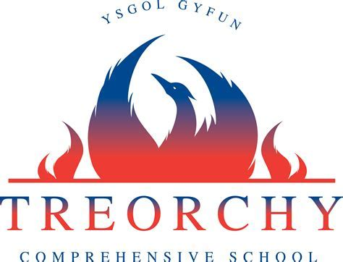  Inclusion  and  Skills  Department  Targeted universal provision includes-  Launchpad Literacy – A multi-sensory literacy intervention, tailored to build literacy skills.  Group Reading – Opportunity to read in small groups in order to gain fluency.  Paired Reading Support - Reading with 6th Form students during morning registration.  Talk Fitness – a group intervention aimed at improving functional and cross-curricular speaking and listening skills.  Numeracy – A multi-sensory group intervention, tailored to build numeracy skills.  Lunch Lounge – Lunch & breaktime provision for students who struggle to cope with the business of the main yard.

